1️⃣ Backpropagation Mechanism (Core of ANN Learning)
🎯 What is Backpropagation?
Backpropagation is the algorithm used to update weights and biases in a neural network using gradient descent.
It answers one main question:
How much did each weight contribute to the error?
And then adjusts it accordingly.
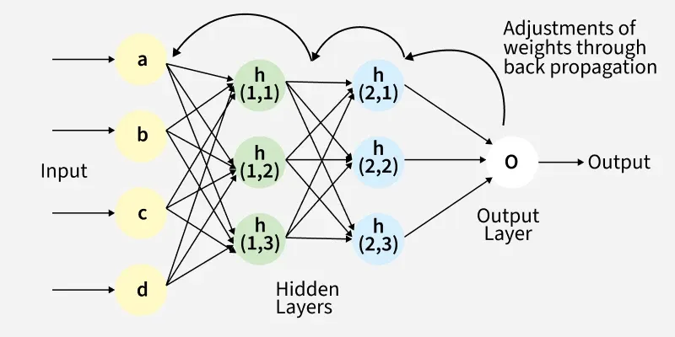
Back Propagation plays a critical role in how neural networks improve over time. Here's why:
- Efficient Weight Update: It computes the gradient of the loss function with respect to each weight using the chain rule making it possible to update weights efficiently.
- Scalability: The Back Propagation algorithm scales well to networks with multiple layers and complex architectures making deep learning feasible.
- Automated Learning: With Back Propagation the learning process becomes automated and the model can adjust itself to optimize its performance.

🧠 Step-by-Step Working
Training happens in 3 main phases:
✅ Step 1: Forward Propagation
Input → Hidden Layers → Output
At each neuron:
$$z=wX+b \\ a=f(z)$$
Where:
- $w$= weight
- $X$= input
- $b$= bias
- $f$= activation function
- $a$= output
Finally, we compute the loss.

✅ Step 2: Compute Loss
Compare predicted output $\hat{y}$with true output $y$.
Loss function tells:
How wrong is the model?

✅ Step 3: Backward Propagation (The Main Part)
We compute:
$$\frac{∂L}{∂w}$$
This tells:
If I slightly change this weight, how much does loss change?
Using Chain Rule from calculus:
$$\frac{∂L}{∂w}=\frac{∂L}{∂a}×\frac{∂a}{∂z}×\frac{∂z}{∂w}$$
This is the heart of backpropagation.

🔁 Weight Update Rule
After computing gradients:
$$w_{new}=w_{old}-η\frac{∂L}{∂w}$$
Where:
- $η$= learning rate
- Gradient = direction of steepest increase
- We subtract because we want to minimize loss

🎯 Why Backpropagation Works
- Uses calculus
- Efficiently computes gradients layer by layer
- Avoids recalculating everything from scratch
- Enables deep networks to learn complex patterns

2️⃣ Mean Squared Error (MSE)
Used mostly for:
- Regression problems
- Continuous output

📌 Formula
$$MSE=\frac{1}{n}∑(y-\hat{y})^{2}$$
Where:
- $y$= actual value
- $\hat{y}$= predicted value
- $n$= number of samples

🎯 Intuition
- Measures squared difference
- Larger errors are penalized more
- Smooth and differentiable

📉 Why Square?
- Avoid negative cancellation
- Penalizes large mistakes heavily
- Makes function convex (for linear models)

🔎 Derivative of MSE
For single output neuron:
$$\frac{∂L}{∂\hat{y}}=2(\hat{y}-y)$$
Simple and smooth → works well for regression.

⚠ Problem with MSE in Classification
If using sigmoid activation:
When output saturates (close to 0 or 1), gradient becomes very small → slow learning.
That’s why we use Cross-Entropy.

3️⃣ Cross-Entropy Loss
Used for:
- Binary classification
- Multi-class classification

🔹 Binary Cross-Entropy (BCE)
Used with Sigmoid activation
$$L=-[ylog⁡(\hat{y})+(1-y)log⁡(1-\hat{y})]$$

🎯 Intuition
- If prediction is correct → small loss
- If prediction is confidently wrong → huge loss
Example:
- True = 1
- Predicted = 0.99 → small loss
- Predicted = 0.01 → huge loss

🔎 Beautiful Property (Very Important)
When using:
Sigmoid + Cross Entropy
Gradient simplifies to:
$$\frac{∂L}{∂z}=\hat{y}-y$$
This is amazing because:
- No multiplication by sigmoid derivative
- No vanishing gradient problem here
- Faster learning
This is why Cross-Entropy is preferred for classification.

🔹 Categorical Cross-Entropy
Used with Softmax activation
$$L=-∑y_{i}log⁡({\hat{y}}_{i})$$
Where:
- $y_{i}$= one-hot encoded vector
- ${\hat{y}}_{i}$= predicted probabilities

4️⃣ How Everything Connects in Training
Let’s see full pipeline:
Input → Forward Pass → Prediction → Loss Function
↓
Backpropagation
↓
Gradient Computation
↓
Weight Update

🧠 MSE vs Cross-Entropy (Interview Table)
Feature | MSE | Cross-Entropy
Used For | Regression | Classification
Output Type | Continuous | Probabilities
Gradient Behavior | Can be small | Strong gradients
Works Best With | Linear output | Sigmoid / Softmax
Learning Speed | Slower for classification | Faster

5️⃣ Why Loss Function Choice Matters
Loss affects:
- Gradient magnitude
- Convergence speed
- Stability
- Final accuracy
Wrong loss function → unstable training.

6️⃣ Deep Understanding (Important Concept)
Backpropagation does NOT mean:
❌ Error travels backward physically
❌ Neurons send signals backward
It means:
We compute derivatives backward using chain rule.
It’s purely mathematical.

7️⃣ Common Interview Questions
❓ Why not use MSE for classification?
Because:
- Gradients become very small when sigmoid saturates
- Learning becomes slow
- Cross-entropy provides stronger gradients

❓ Why Cross-Entropy works well with Softmax?
Because it maximizes likelihood (based on probability theory).
It is derived from:
Maximum Likelihood Estimation (MLE)

❓ What happens if learning rate is too high?
- Overshooting
- Oscillation
- Divergence

8️⃣ Intuition in One Line
- Loss function = Measures error
- Backpropagation = Calculates responsibility
- Gradient descent = Corrects weights

